Real Time Template
Juan M. Gago
Version 4 – June 31, 2007

Host PC Code (Visual C)

This application obtains the FFT of a static image of size 32 x 1024 32-bits pixels in real- time.

Firstly the Host PC downloads the image (read from the same RAM position) in the memory of the DSP board. There, the master DSP will transmit it line by line (we assume a line transfer rate of 1 KHz) to the slave processors. When the master DSP has received the processed-image from the slaves, the Host PC reads the result (we use the semaphores input and output to access to the common area of the SDRAM used by both the Host PC and the Master DSP).

NUM_FRAMES = 4 frames
FRAME_SIZE = 32 lines
LINE_SIZE = 1024 pixels
LINE_FREQ = 1 KHz

WHILE (frame_cnt < NUM_FRAMES)

download_image(processor1, 0x800000)
input = 1

WHILE (!output)
output = 0
upload_image(processor1, 0x1000000)

Master DSP Code (HH1)

If we wait for the completation of the DMA transference over MMS (Multiprocessor Memory Space) there will not be process any parallelism.

FOR ( frame_cnt = 0; frame_cnt < NUM_FRAMES; frame_cnt++ )

addr1 = 0x800000
addr2 = 0x1000000

WHILE (!input)
input = 0

do
read_line(addr1+offset, DMA10, Wait)
SetIOP(MSGR0, 1);

process_line_piece(MMS)
wait for interrupt IRQ2

transpose_line(MMS)
SetIOP(MSGR0, 1);

process_line_ piece(MMS)
wait for interrupt IRQ2

write_line(addr2+offset, DMA10, Wait)

WHILE (1 < offset < FRAME_SIZE)

output = 1

Slave DSP Code (HH2)

WHILE (!GetIOP(MSGR0) );
SetIOP(MSGR0, 0);

process_line_piece(MMS)
interrupt to Master DSP (via FLAG2)

WHILE (!GetIOP(MSGR0) );
SetIOP(MSGR0, 0);

process_line_piece(MMS)
interrupt to Master DSP (via FLAG2)

Slave DSP Code (HH2 and HH3)

WHILE (!GetIOP(MSGR0) );
process_line_piece(MMS)

WHILE (!GetIOP(MSGR0) );
process_line_piece(MMS)

Timing of the BittWare Libraries

The next figure details the set up chosen to interconnect the different DSP’s.

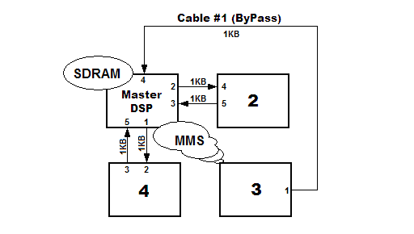
Figure 2 DSPs Interconnection

Library extint0.h: extmem_to_intmem(addr1, DMA10)
intmem_to_extmem(addr2, DMA10)

The extmem_to_intmem(addr1, DMAC10) function provides 4KB (size of a line) from the SDRAM to MMS each ms via DMA. We pretend in this way to simulate the line-capture by the camera at a programmed line-rate (1 KHz).

Data Input = 4KB @ 320 MB/s = 12.5 us

We have tested that preparing the transference of theses 4KB takes:

Data Input = (0x1E71 – 0x14FD) ×12.5 ns = 30.2 us*

The intmem_to_extmem(addr2, DMAC10) function writes 4KB (size of a processed line) from the MMS to SDRAM via DMA. We have tested that preparing the transference of theses 1KB takes:

